Conclusion
This section summarises how social wellbeing is changing over time in New Zealand and how social wellbeing is distributed across different population subgroups. For the first time, we also draw some tentative conclusions about how social wellbeing varies across different parts of the country.

Changes in social wellbeing over time
We have new data for 25 of the 42 indicators used in this year’s edition of the report. The pattern of change shown in the report is broadly consistent with the picture revealed by The Social Report 2004. The key addition to the 2005 report is new data showing what has happened to indicators of economic living standards since 2001. This shows an overall decline in the proportion of the population on low incomes, an overall decline in the proportion of households spending more than 30 percent of their income on housing costs, and a slight increase in overall income inequality.
Figure CO1 compares the most recent figures with those of the mid-1990s to show how wellbeing has changed over the past decade. Sixteen of the 22 indicators for which we have comparable data have shown some improvement, three have deteriorated slightly, and three show no significant change.

Figure CO1 Changes in social wellbeing, 1995–1997 to 2002–2004
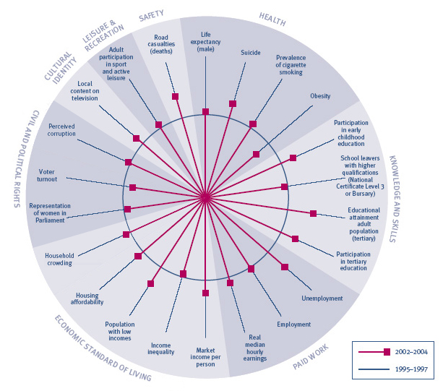
Interpreting “Changes in social wellbeing, 1995–1997 to 2002–2004”
The circle represents average performance against each indicator between 1995 and 1997, and the spokes represent the most recent performance, where possible averaged over the most recent three years. Where a spoke falls outside of the circle, this means outcomes have improved since the mid-1990s; the further from the circle it falls, the more significant the improvement. Where a spoke falls within the circle, outcomes in this area have | deteriorated since the mid-1990s; the further the spoke is from the circle, the more pronounced the deterioration. There are, however, some important limitations on this style of presentation. In particular, we cannot directly compare the size of changes for different indicators. The absence of trend data for some indicators also means we can only show 22 of the 42 indicators used in The Social Report 2005.

Time-series data going back to the mid-1980s is also available for a smaller number of indicators. This data, in combination with the data used in Figure CO1, shows three main patterns of change over the past two decades.

As shown in previous editions of the social report, indicators of life expectancy, cigarette smoking, participation in early childhood and tertiary education, the educational attainment of the adult population and road casualties have improved on a fairly consistent basis since the mid-1980s.
One group of indicators
has improved consistently, or remained strong, since the mid-1980s
The representation of women in Parliament steadily increased between the mid-1980s and 1999, though it declined marginally in the 2002 election. New Zealand has consistently demonstrated very low levels of perceived corruption since surveys began in 1997.

Market income per person, unemployment, employment, housing affordability, the proportion of the population on low incomes, income inequality and suicide all deteriorated between the late-1980s and early-1990s.
Another group of indicators – many of them in the Paid Work and Economic Standard of Living domains – worsened during the late-1980s and early-1990s, but have improved since then
Market income per person has been steadily increasing since the mid-1990s. Employment, unemployment and low incomes began to recover in the mid-1990s, plateaued or deteriorated slightly towards the end of the 1990s, and have been improving steadily since then. Housing affordability began to improve towards the end of the 1990s.
Market income per person, unemployment and employment have all now returned to, or are better than, levels recorded in the mid-1980s. However, neither the proportion of the population on low incomes nor housing affordability has returned to the levels of the mid-1980s.
The proportion of people living in crowded housing has also decreased since the early-1990s but we do not have trend data to show how this compares with the mid-1980s. Real median hourly earnings have increased since 1997 when the New Zealand Income Survey began.
Suicide rates began to improve towards the end of the 1990s and are now lower than they were in the mid-1980s.

Voter turnout, obesity and income inequality have all worsened since the mid-1980s. The growth in income inequality since the mid-1990s has occurred despite a decline in the proportion of the population on low incomes over that same period. This suggests that, while incomes at the lower end of the income distribution have grown, growth at the middle and upper ends of the distribution has been stronger.
A small group of indicators appear to be in long-term decline or to be static
Child maltreatment deaths almost doubled between the mid to late-1980s and there has been very little change since then.
There was little change in the proportion of school leavers with higher qualifications from the early 1990s through to 2002. 2003 data shows an increase against this indicator.

Variation in social wellbeing across the country
In this section we draw some conclusions about the distribution of social wellbeing across regions. Due to space constraints, it is not possible for The Social Report 2005 to include full subnational data for each of the indicators. However, the additional information upon which this section is based is provided on the social report website (www.socialreport.msd.govt.nz).
Variations in social wellbeing will, to some extent, be driven by the different demographic profiles of communities, and in particular their age distributions. For example, regions with disproportionately youthful populations will be more likely to perform poorly for those indicators against which children and young people tend to do poorly.
Reporting on the average level of wellbeing in a region will also obscure variation in outcomes within that region. Therefore, while the 16 regions we report on contain a diverse range of communities with a diverse range of outcomes, this will not be apparent from the data on average regional outcomes.
We have some regional data for 19 of the report’s 42 indicators.92 It is important to emphasise that the picture of social wellbeing presented here is only a partial one because of the limited size of the indicator set for which we have comparable data. However, the indicator set does include a number of key indicators, including life expectancy, cigarette smoking, participation in early childhood education, school leavers with higher qualifications, adult educational attainment, unemployment, median hourly earnings, low incomes, household crowding, participation in sport and active leisure, and telephone and internet access.
Canterbury, Wellington and Nelson are in the top quartile for at least half of the 18 indicators93, and are in the lower quartile for no more than two indicators. Northland, Gisborne and the West Coast are in the lower quartile for more than half of the 18 indicators.
We can draw tentative conclusions about how indicators of social wellbeing vary across the regions in only some of the social report outcome domains.
In the Health domain, Auckland, Canterbury and Wellington perform well for life expectancy. Conversely, life expectancy is lowest in Gisborne, Northland and Southland. Wellington, Auckland and Canterbury have smoking rates below the national average of 25 percent. Northland, the West Coast, Gisborne and the Bay of Plenty have higher than average rates.
In the Knowledge and Skills domain, early childhood participation is consistently high across all of the seven South Island regions. For both the proportion of school leavers with higher qualifications and the educational attainment of their adult populations, Auckland, Wellington, Canterbury and Otago perform well. All of these regions have large universities within their boundaries. The levels of these indicators are not as high for the West Coast and Northland. There is a wide variation in outcomes for the proportion of school leavers with higher qualifications, ranging from 75 percent in Otago through to 51 percent in the West Coast.
In the Paid Work domain there was relatively little variation in regional unemployment rates in 2004, and they are low by both historical and international standards across all of the 16 regions. There is a larger degree of variation in regional employment rates, ranging from a high of 78 percent in Southland, to 69 percent in Northland. The South Island regions (with the exception of Otago) do particularly strongly for indicators of both employment and unemployment.
Median hourly earnings are the highest in Wellington and Auckland and the lowest in Otago, and the combined area of Tasman, Nelson, Marlborough and the West Coast. There is a considerable degree of variation in workplace injury rates across the regions. This reflects the higher concentration of workers in higher-risk industries (such as agriculture and forestry) in regions such as Gisborne, Northland, the Hawke’s Bay and the Bay of Plenty. Workplace injuries are lowest in urban areas where workers are more concentrated in lower-risk white-collar jobs.
In the Economic Standard of Living domain, the proportion of the population with low incomes ranges from a low of 20 percent in Wellington to 29 percent in Gisborne. Other regions with relatively high proportions of people with low incomes are Northland, Otago and the West Coast. There are relatively low rates of household crowding across all seven South Island regions. Household crowding is most prevalent in Auckland, Northland and Gisborne.

The distribution of social wellbeing in New Zealand

Outcomes for Mäori and Pacific peoples have improved since the mid-1990s against most of the indicators for which we have time-series data. This includes longer life expectancy, reduced rates of suicide (data for Mäori population only), and higher rates of participation in early childhood and tertiary education. Unemployment and employment rates have also improved.
Most of the indicators for which we have time-series data show that outcomes have improved for Mäori
and Pacific peoples since
the mid-1990s
The proportion of families with a Mäori adult with low income dropped from 32 percent in 2001 to 24 percent in 2004, and the proportion spending more than 30 percent of their income on housing costs declined from 32 percent to 21 percent over the same period. While the proportion of families with a Pacific adult with low income has changed little since 2001, the proportion spending more than 30 percent of their income on housing costs has dropped sharply from 41 percent to 23 percent.
As with the rest of the population, rates of obesity have grown since 1997, and there has been no improvement in the number of child maltreatment deaths (data for Mäori population only).
Against many of these indicators, improvements for Mäori have been greater than for Europeans/Päkehä. This includes indicators of life expectancy, suicide, participation in early childhood and tertiary education, school leavers with higher qualifications, employment, unemployment, low incomes and housing affordability. While the effect of this has been to reduce the disparity in outcomes between the Mäori and Päkehä/European populations, indicators of wellbeing for Mäori are still relatively poor in a number of areas, and in particular Health, Paid Work and Economic Standard of Living. This is illustrated in Figure CO2 on the next page.
Figure CO2 Social wellbeing for Mäori, relative to Europeans/Päkehä
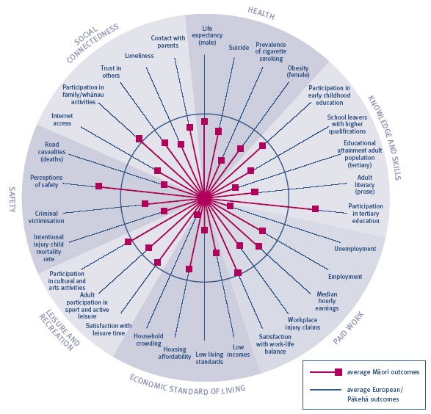
Interpreting “Social wellbeing for Mäori, relative to Europeans/Päkehä”
The circle represents average outcomes for Europeans/Päkehä against each indicator and the spokes represent outcomes for Mäori. Where a spoke falls outside of the circle this means outcomes for Mäori are better than for Europeans/Päkehä; the further the spoke is from the circle the more pronounced the difference. | Where a spoke falls within the circle, outcomes for Mäori are worse than for Europeans/Päkehä; the further the spoke is from the circle the more pronounced this effect. There are, however, some important limitations on this style of presentation. In particular, we cannot directly compare the size of changes for different indicators.

Improvements for Pacific peoples have been greater than for Europeans/Päkehä for a smaller number of indicators, including housing affordability, median hourly earnings, and participation in early childhood education. However, as shown in Figure CO3, outcomes for Pacific peoples are still relatively poor against the large majority of indicators.
Figure CO3 Social wellbeing for Pacific peoples, relative to Europeans/ Päkehä
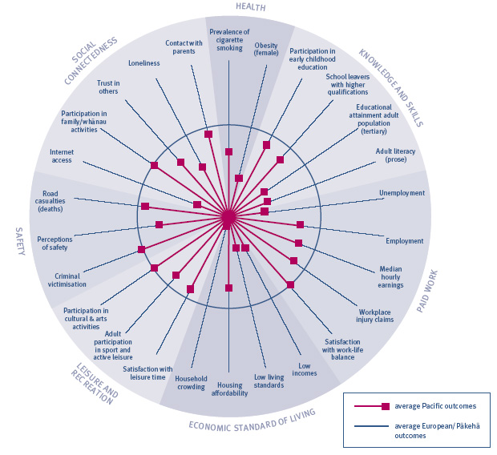
Interpreting “Social wellbeing for Pacific peoples, relative to Europeans/Päkehä”
The circle represents average outcomes for Europeans/Päkehä against each indicator and the spokes represent outcomes for Pacific peoples. Where a spoke falls outside of the circle this means outcomes for Pacific peoples are better than for Europeans/Päkehä; the further the spoke is from the circle the more pronounced the difference. | Where a spoke falls within the circle, outcomes for Pacific peoples are worse than for Europeans/Päkehä; the further the spoke is from the circle the more pronounced this effect. There are, however, some important limitations on this style of presentation. In particular, we cannot directly compare the size of changes for different indicators.

The limited set of indicators that enables us to look at the outcomes for people who identify with ethnicities other than European/Päkehä, Mäori or Pacific peoples show a mixed picture.
People who identify with an ethnic group other than European/Päkehä, Mäori or Pacific peoples tend to perform well on average in the area of Knowledge and Skills, and have relatively low rates of smoking. While employment, unemployment and median hourly earnings outcomes for people in this group are better than for the Mäori and Pacific populations, they are not as good as for Päkehä/Europeans.
There is a mixed pattern of performance for people
who identify with
ethnicities other than European/Päkehä, Mäori,
or Pacific peoples
Families with an adult of “Other” ethnicity were the only group to experience an increase in the proportion of people on low incomes and in the proportion of people spending more than 30 percent of their income on housing between 2001 and 2004. Outcomes for this group are now worse for these two indicators than for any other ethnic group.

Women have significantly lower representation in Parliament than men and are less likely than men to feel safe in their communities. Unemployment rates are slightly higher among women than men, and women are more likely to have low living standards and lower median hourly earnings. However, growth in real median hourly earnings since 1997 for women has been double the growth rate experienced by men. Since the mid-1990s, the employment rate gap between males and females has narrowed. While between the mid-1990s and 2001 women were slightly more likely than men to be on low incomes and to be spending more than 30 percent of their income on housing costs, by 2004 these differences in outcomes had virtually disappeared. Rates of obesity are higher among the female population, but this gap has narrowed due to a growth in male obesity rates since 1997.
While differences by sex remain across a number of areas, the disparity in outcomes has narrowed for some key indicators
Men have higher rates of suicide and lower life expectancy and health expectancy than women. The sex gap in outcomes for life expectancy and suicide has narrowed since the mid-1990s, but has increased for health expectancy. Men are more likely than women to experience a workplace or road traffic injury, and are less likely than women to leave school with higher qualifications or to participate in tertiary study. The gap in outcomes for these last two indicators has widened over the past decade.
Figure CO4 Social wellbeing for women, relative to men
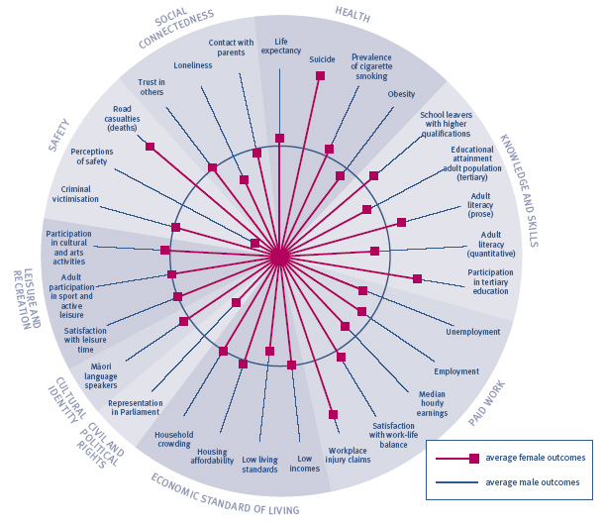
Interpreting “Social wellbeing for women, relative to men”
The circle represents average outcomes for men against each indicator and the spokes represent outcomes for women. Where a spoke falls outside of the circle this means outcomes for women are better than for men; the further the spoke from the circle the more pronounced the difference. Where a spoke falls within the | circle outcomes for women are worse than for men; the further the spoke is from the circle the more pronounced this effect. There are, however, some important limitations on this style of presentation. In particular, we cannot directly compare the size of changes for different indicators.

The proportion of children living in low-income families declined from 27 percent in 2001 to 21 percent in 2004. Child poverty rates are still higher, however, than for the rest of the population (19 percent) and other indicators show children are more likely than adults to live in families with low living standards, families that are spending more than 30 percent of their incomes on housing, and families living in crowded housing.
Outcomes for children and young people have
improved against some key indicators but remain
relatively poor in a
number of areas
Younger people are considerably more likely to experience criminal victimisation and road casualties, and are more than twice as likely as older age groups to be unemployed.
People aged 65 and over have relatively good outcomes in the Economic Standard of Living domain. They also have lower rates of obesity, smoking and suicide than young people. However, older people are less likely to have higher qualifications, to participate in family activities, or to participate in cultural activities.
SUMMARY OF INDICATORS
Indicators | Current overall level of indicator (most recent year) | Variation within the population | Is this aspect of the quality of life improving overall? | How does this aspect of the quality of life compare with the OECD?
Health
Health expectancy | 64.8 years for males and 68.5 years for females (2001) | Lower for males and Mäori | Improved for females | No comparison available
Life expectancy | 77.0 years for males and 81.3 years for females (2002/2004) | Lower for males, Mäori and Pacific peoples and those living in deprived areas | Improving, faster for males than females | Average for both males and females
Suicide | 10.7 per 100,000 (age-std rate for all ages); youth 15–24 years, 17.0 per 100,000 (2002) | Suicide deaths higher for males, youth, young adults and Mäori; attempted suicide higher for females | Improved since 1998 | Average for all ages, poor for youth
Prevalence of cigarette smoking | 25 percent of population aged 15 years and over smoke cigarettes (2002) | Higher rates among young people, Mäori, Pacific peoples and those living in deprived areas | Improved to 1991, steady since | Good for males, poor for females
Obesity | 21 percent of population 15+ (2003); 10 percent of children 5–14 years (2002) | Higher for Pacific peoples, Mäori and females in deprived areas | Prevalence of obesity doubled between 1977 and 2003 | Poor

Indicators | Current overall level of indicator (most recent year) | Variation within the population | Is this aspect of the quality of life improving overall? | How does this aspect of the quality of life compare with the OECD?
Knowledge and Skills
Participation in early childhood education | “Apparent” participation rate of 95 percent for 3 year olds and 103 percent for 4 year olds (2004) | Mäori and Pacific rates lower than non-Mäori | Improving | No robust comparison available
School leavers with higher school qualifications | 67 percent of school leavers with at least NCEA Level 2 (2003) | Proportions lower for males, Mäori and Pacific school leavers | Improved to 1991, slight decline since 1998, but increased in last year | No comparison available
Adult literacy skills in English | 54 percent of people aged 15–65 have a level of prose literacy in English needed to meet the complex demands of everyday life and work; 50 percent meets the same standard for document literacy; 51 percent for quantitative literacy (1996) | Literacy levels lower among older people, Mäori, Pacific peoples and “Other” ethnic groups | No trend available | Average for prose literacy, but below average for document and quantitative
Educational attainment of the adult population | 79 percent of the population aged 25–64 years with at least an upper secondary qualification; 16 percent of the population aged 25–64 years with tertiary (bachelor degree+) qualifications (2004) | Proportions lower for older people, women, Mäori and Pacific peoples | Improving | Good for upper secondary and average for tertiary
Participation in tertiary education | 12 percent of population aged 15 and over enrolled in tertiary education institutions (2004) | Lower rates for males, students from deprived areas; higher for Mäori at ages under 18 and over 25 | Improving | No direct comparison available for total population aged 15 and over. Average for 20–29 year olds

Indicators | Current overall level of indicator (most recent year) | Variation within the population | Is this aspect of the quality of life improving overall? | How does this aspect of the quality of life compare with the OECD?
Paid Work
Unemployment | 3.9 percent of the labour force (2004) | Higher rates for young people, Mäori, Pacific and “Other” ethnic groups | Improving since 1998 almost to  mid-1980s levels | Very good
Employment | 73.5 percent of the population aged 15–64 years (2003) | Lower rates for young people, women, Mäori, Pacific peoples and “Other” ethnic groups | Improved since 1998 to above  mid-1980s levels | Good
Median hourly earnings | $15.34 per hour for wage and salary earners ($16.50 for males; $14.40 for females) (2004) | Lower for Mäori, Pacific peoples, youth and females over 30 | Improving | No comparison available
Workplace injury claims | 146 claims per 1,000 full-time equivalent employees (2003) | Higher rates for men and Mäori | No change over past year | No comparison available
Satisfaction with work-  life balance | 66 percent of employed people say they are satisfied with their work-life balance (2004) | Men, Mäori, people of “Other” ethnicity and people whose personal incomes are more than $60,000 are less likely to be satisfied with their work-life balance | No data | No comparison available

Indicators | Current overall level of indicator (most recent year) | Variation within the population | Is this aspect of the quality of life improving overall? | How does this aspect of the quality of life compare with the OECD?
Economic Standard of Living
Market income per person | RGNDI of $28,360 per capita (in constant 1995/1996 dollars) (2004) | Not measured | Improving | Poor
Income inequality | The household in the 80th percentile has an income 2.8 times that of the household in the bottom 20th percentile (2004) | Not relevant | Worsening slightly | Poor in the mid-1990s
Population with low incomes | 19 percent of population lives in economic family units with incomes below 60 percent of median (2004) | Higher rates among children, large families, sole parents, Mäori or Pacific families, families from “Other” ethnic groups, families who rely on income-tested benefits and families in rented dwellings | Recent improvement | Better than OECD median in mid-1990s
Population with low  living standards | 20 percent of the total population with restricted living standards (ELSI Levels 1–3) (2000) | As for population with low incomes | No trend data available | No comparison available
Housing affordability | 22 percent of households spend more than 30 percent of income on housing (2004) | Higher proportions among Mäori, Pacific peoples or “Other” ethnic groups | Worsened to 1998 then stable | No comparison available
Household crowding | 10 percent of individuals live in households requiring one or more additional bedrooms (2001) | More common among families with young children, youth, people in rental housing, Mäori and Pacific peoples and in South Auckland | Some improvement | No comparison available

Indicators | Current overall level of indicator (most recent year) | Variation within the population | Is this aspect of the quality of life improving overall? | How does this aspect of the quality of life compare with the OECD?
Civil and Political Rights
Voter turnout (general elections) | 72.5 percent of the population eligible to vote (2002) | Non-voters more likely to be on lower incomes, younger people, Mäori or Pacific peoples | Worsened | Above average
Representation of  women in government | 28 percent of seats in Parliament (2002 general election); 31 percent of elected members (2001 local authority elections) | Not relevant | Improvement, then marginal  decline in latest year | Good
Perceptions of discrimination | Asians most common group perceived to be subject to discrimination (2004) | Not relevant | Deteriorated for people who are overweight, people with disabilities | No comparison available
Perceived corruption | New Zealand ranked second least corrupt nation with a Corruption Perceptions Index score of 9.6 (2004) | Not relevant | Steady | Very good

Indicators | Current overall level of indicator (most recent year) | Variation within the population | Is this aspect of the quality of life improving overall? | How does this aspect of the quality of life compare with the OECD?
Cultural Identity
Local content programming on New Zealand television | 42 percent of the prime-time schedule (2004) | Not relevant | Steady | Below average
Mäori language speakers | 25 percent of Mäori report conversational fluency in Mäori (2001) | Fluent speakers more likely to be older | No trend available | Not relevant
Language retention | Varied from 17 percent of Cook Islands Māori to 81 percent of Koreans (2001) | Not relevant | No trend available | No comparison available

Indicators | Current overall level of indicator (most recent year) | Variation within the population | Is this aspect of the quality of life improving overall? | How does this aspect of the quality of life compare with the OECD?
Leisure and Recreation
Satisfaction with  leisure time | 80 percent of the population are satisfied overall with their leisure time (2004) | Those aged 25–49 years and Asian/Indian people report lower satisfaction rates | No trend available | No comparison available
Participation in cultural and arts activities | 93 percent of adult population took part in cultural activities (2001/2002) | Higher participation rates among young people | No trend available | No comparison available
Participation in sport  and active leisure | 70 percent of adults 18 and over, 66 percent of young people 5–17 years were physically active (2000/2001) | Girls, Pacific young people and Mäori and Pacific adults were less likely to be physically active | Overall improvement, particularly for older adults; deterioration for Mäori and Pacific young people | No comparison available
Physical Environment
Air quality | Average annual PM₁₀ levels were above guidelines in Christchurch in 2004. Auckland exceeded the guideline in 2004. Wellington was below the threshold in 2004. Dunedin reached the threshold level in 2004. Hamilton has been consistently below the New Zealand annual guideline | Not reported | Steady | No comparison available
Drinking water quality | E. coli compliance increased from 71 percent in 2001 to 82 percent in 2003. Cryptosporidium compliance fluctuated from 74 percent in 2001, to 81 percent in 2002, to 73 percent in 2003 | Not reported | Steady | No comparison available
Indicators | Current overall level of indicator (most recent year) | Variation within the population | Is this aspect of the quality of life improving overall? | How does this aspect of the quality of life compare with the OECD?
Safety
Intentional injury child mortality | In the five years to 2000, 49 children died as a result of maltreatment, an average of one child per 100,000 children per year | Higher for children under 5 years | Improving slightly | Poor
Criminal victimisation | 30 percent of population aged over 15 years were victims of criminal offending, either as individuals or members of households (2000) | Younger people and Mäori more likely to have been a victim of crime | Similar to 1995 level | No reliable comparison  available
Perceptions of safety | 29 percent of population felt unsafe walking alone in their neighbourhood after dark (2001) | Perceptions more negative among females and Pacific peoples | No trend available | No comparison available
Road casualties | 10.7 deaths per 100,000 population (2004, provisional) | High rates among men, young people, Mäori, and those aged 65 and over | Improvement since 1986 | Average

Indicators | Current overall level of indicator (most recent year) | Variation within the population | Is this aspect of the quality of life improving overall? | How does this aspect of the quality of life compare with the OECD?
Social Connectedness
Telephone and internet access in the home | 97 percent of adult population have access to telephone and 41 percent to internet in their homes (2000) | Access less likely among Mäori and Pacific families, families with unemployed adults and sole-parent families | No trend available | Above average for internet
Participation in family/whänau  activities and regular contact with  family/friends | 71 percent of adults had family or friends over for dinner at least once a month in the previous year and 87 percent engage in family/whänau activities (2000) | Older people and Europeans less likely to be involved in family activities | No trend available | No comparison available
Trust in others | 69 percent of people aged 15 and over report that people can be trusted (2004) | Women, Mäori, Pacific peoples and those with incomes less than $20,000 report lower levels of trust | Improving | Good
Loneliness | 18 percent of people aged 15 and over report having felt lonely in the past 12 months (2004) | People of “Other” ethnicity, young people, people whose incomes are less than $20,000, unemployed people and unpartnered people report higher levels of loneliness | No trend available | No comparison available
Contact between young people and their  parents | 63 percent of male and 61 percent of female students spent enough time with Mum and/or Dad (2003) | Mäori students more likely to report not getting enough time with their Mum and/or Dad | No trend available | No comparison available

